Project Design Phase
Problem – Solution Fit
Date | 09 September 2026
Student Name | Jetti Harika
Project Name | Automated Network Request Management in ServiceNow
Maximum Marks

Problem–Solution Fit
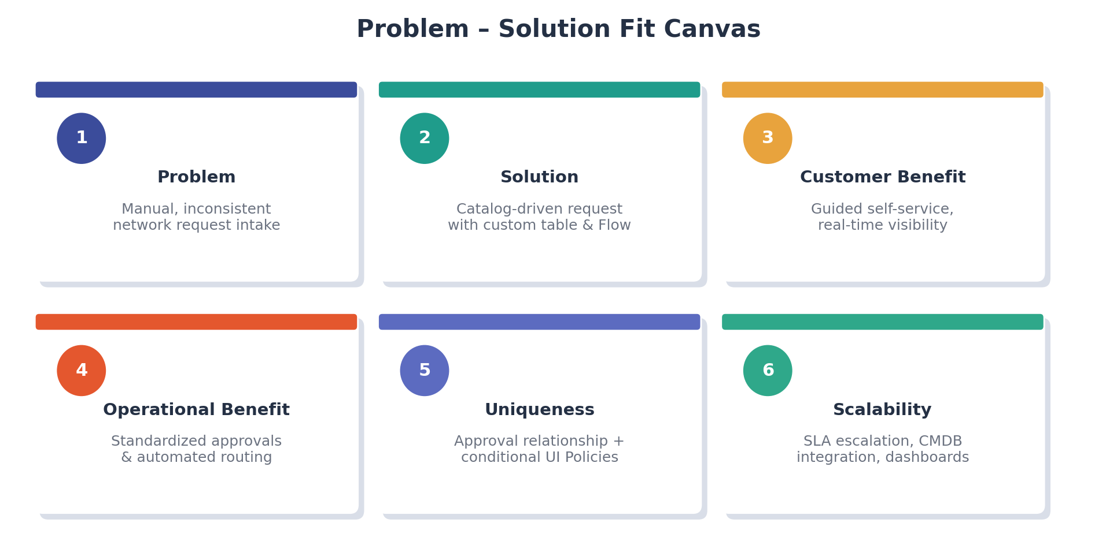
Figure 1: Problem–solution fit canvas adapted to the Automated Network Request Management project.
The canvas below maps the operational problem behind manual network request handling to the ServiceNow-based solution implemented for the Automated Network Request Management project.
Parameter | Project Fit
Problem | Network teams and end users lack a standardized way to submit, route, and track network-related service requests (new connections, access changes, device requests), resulting in delays, manual follow-ups, and inconsistent request data.
Solution | A ServiceNow Automated Network Request Management application that captures network requests through a Service Catalog item, stores them in a dedicated custom table, routes them for approval, and automates fulfilment using Flow Designer.
Customer Benefit | Requesters get a guided, self-service form with clear fields, dynamic UI logic, and real-time visibility into request status and approvals.
Operational Benefit | Network and IT teams gain a centralized, structured dataset with enforced mandatory fields, standardized approval routing, and automated notifications, reducing manual triage effort.
Uniqueness | Combines a purpose-built network request data model, a custom relationship linking approval records (sysapprovals) to the request table, conditional UI Policies for device and connection type, and end-to-end Flow Designer automation (create record, request approval, send email, update record).
Scalability | The solution can be extended with SLA-based escalation, CMDB integration for network configuration items, richer reporting/dashboards, and additional request types beyond the initial scope.

